**Angular Training Assignment**

An app with 6 different routes with Lazy Loading feature in the app, All Routes should be dynamically loaded.

1. **Route-1 :** To show the Look and feel of the following Image on the Page



1. **Route-2:**  An e-commerce category page which displays 40 products in a page with Grid View / List View and with Price filters as drop downs e.g Grid view 4 items per row, List view 2 item per row

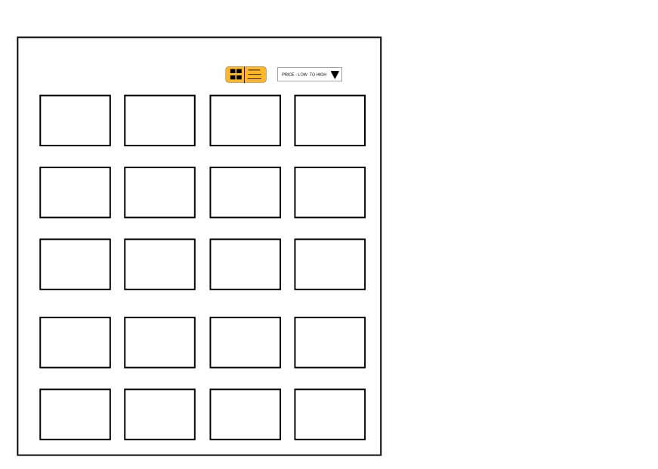

1. **Route-3 :** A count down timer page with four sibling components in it.

Solve this timer app by using Input and Output Decorators

Component-1 – Display the count down timer

Component-2 - Takes input of Timer limit with Start/Pause and reset functionality

Component-3 - Logs the time stamps Button clicks of start or pause or reset Component-4 - Keeps a count of Clicks of Start and Pause functionality

e.g Upon entering 2000, in component-2 and clicking on start, the component -1 should start a countdown timer from 2000, 1999, 1998 … component-3 keeps a log of time stamps , component-4 keeps track of clicks

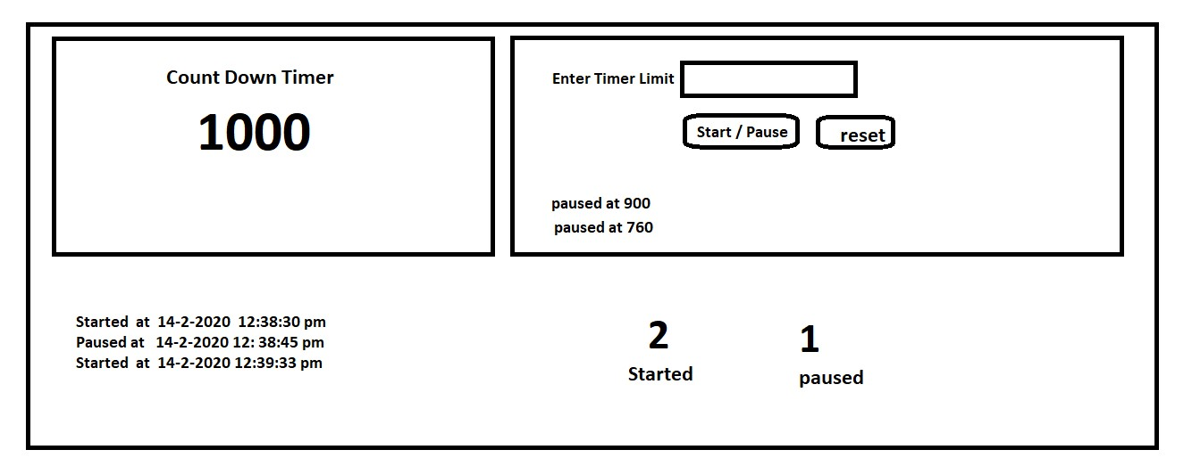

1. **Route-4 :** Same Timer app instead of Using Input and output decrorators do it by using Service using Subject.

1. Route-5 : A Simple Student marks table dynamically populated from a API or JsON. Populate the Headings by using the Keys of the Data Object. Upon first click on the respective heading, sort the data in Ascending , Upon second click sort the data in descending , upon the third click reset the data to initially received data.

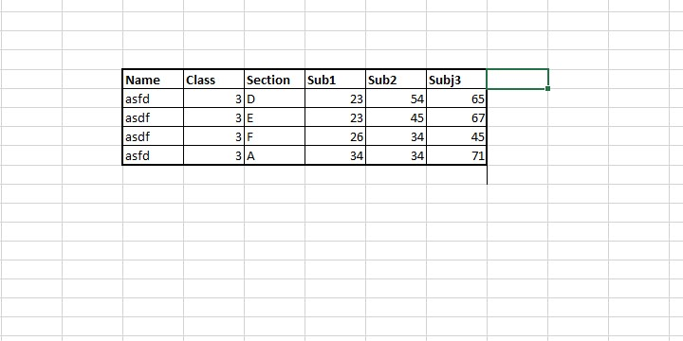

1. **Route-6:** Dynamically create div’s on the page with 200x 200 dimensions. Each div will have a button inside it. If I click on the button of 10th div should show alert Button ‘10’ is clicked. As and when I scroll down, it should load the divs dynamically.

..e.g Button in 10th div clicked, Button in 30th div clicked etc